Post Office Box 265
The Bronx, New York
10464-0265
www.bceq.org
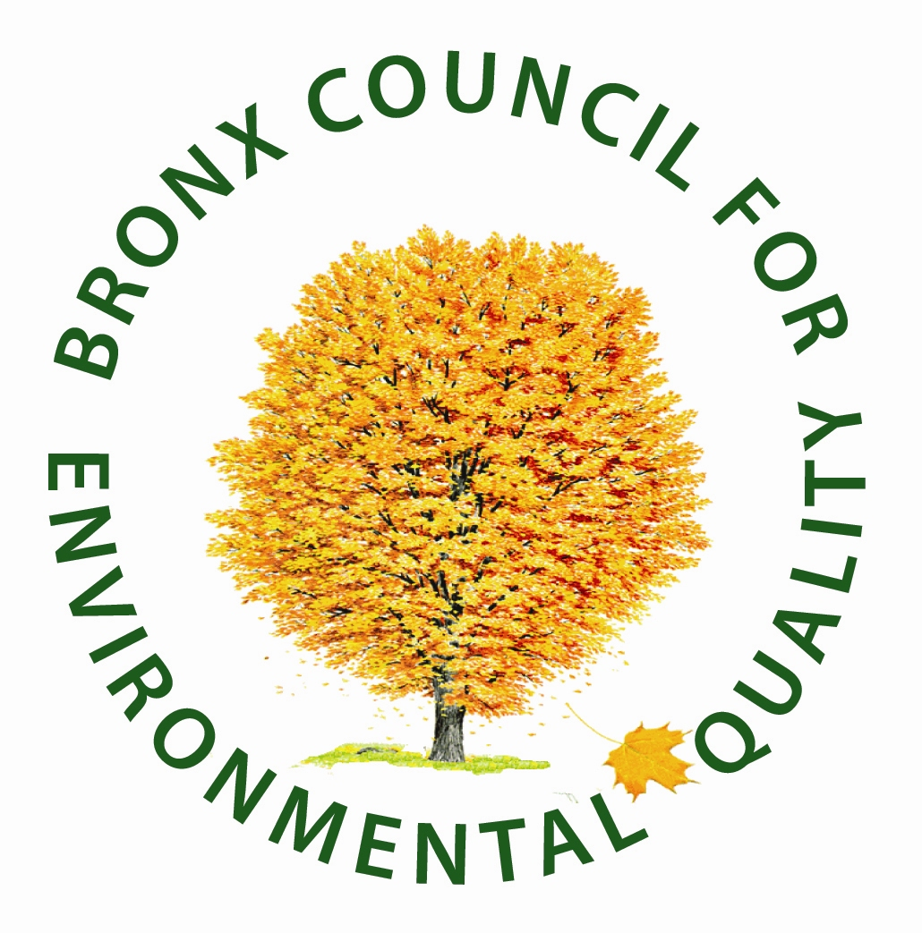

April 26, 2013
Dear Bronx Educator or Environmentalist:
Founded in 1971, the Bronx Council for Environmental Quality (BCEQ) has been the borough’s driving force for the preservation and improvement of parks and open spaces, watershed protection, improvements in wastewater treatment, and responsible land use, including green roofs. We were incorporated in 1972, making this our 40th Anniversary.
BCEQ is soliciting nominations for its Annual Environmental Education Awards. The first award was initiated in 1987 by one of BCEQ’s founders, Helen C. Reel, to honor civic-minded Bronx educators who demonstrate concern for posterity through their efforts to preserve the excellent, enhance the good, and upgrade the mediocre in our beautiful borough.
In 2010, BCEQ will recognize three individuals who have helped further the quest for a safe, healthy environment in which to work and play in the Bronx:
• BCEQ Founder Helen C. Reel “Keeping it Reel” Formal Educator Award
• Gouverneur Morris Non-formal/Community Educator Award
• BCEQ Founder Theresa Lato Student Award
You can nominate people in any or all of the three categories (One nomination per form, please). Send Awards Nomination Forms (attached) to Dena Robins by May 20, 2013.
Community and Pedagogically yours,

Dena K. Robins
Dr. Dena K. Robins
Education Committee Chairperson

“This magistrate is not the king. The people are the king.” Gouverneur Morris
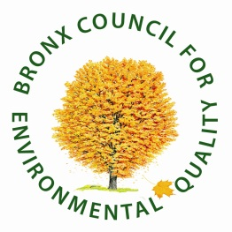
B.C.E.Q. Education Awards
Nomination Forms 2013

Check Category (One nomination per form)
[ ] Helen C. Reel “Keeping it Reel” Educator Award for Formal Educators
[ ] Gouverneur Morris Award for Non-Formal/Community Educators
[ ] Theresa Lato Student Award

NAME OF NOMINEE__________________________________________________________
EDUCATIONAL INSTITUTION_________________________________________________
DISTRICT____________________________________________________________________
ADDRESS____________________________________________________________________
ZIP CODE__________________________________PHONE___________________________
NAME OF NOMINATOR_______________________________________________________
PHONE________________ RELATIONSHIP TO NOMINEE________________________
REASON FOR NOMINATION (attach supporting documents as appropriate)
______________________________________________________________________________
______________________________________________________________________________
______________________________________________________________________________
______________________________________________________________________________
______________________________________________________________________________
Please send before May 20, 2013 to Dena Robins, BCEQ Education Committee Chair, by Email: dena.robins@bceq.org or Fax to Dena at 888-763-8399

B.C.E.Q. Education Awards
Nomination Forms 2013

Check Category (One nomination per form)
[ ] Helen C. Reel “Keeping it Reel” Educator Award for Formal Educators
[ ] Gouverneur Morris Award for Non-Formal/Community Educators
[ ] Theresa Lato Student Award

NAME OF NOMINEE__________________________________________________________
EDUCATIONAL INSTITUTION_________________________________________________
DISTRICT____________________________________________________________________
ADDRESS____________________________________________________________________
ZIP CODE__________________________________PHONE___________________________
NAME OF NOMINATOR_______________________________________________________
PHONE________________ RELATIONSHIP TO NOMINEE________________________
REASON FOR NOMINATION (attach supporting documents as appropriate)
______________________________________________________________________________
______________________________________________________________________________
______________________________________________________________________________
______________________________________________________________________________
______________________________________________________________________________
Please send before May 20, 2013 to Dena Robins, BCEQ Education Committee Chair, by Email: dena.robins@bceq.org or Fax to Dena at 888-763-8399

B.C.E.Q. Education Awards
Nomination Forms 2013

Check Category (One nomination per form)
[ ] Helen C. Reel “Keeping it Reel” Educator Award for Formal Educators
[ ] Gouverneur Morris Award for Non-Formal/Community Educators
[ ] Theresa Lato Student Award

NAME OF NOMINEE__________________________________________________________
EDUCATIONAL INSTITUTION_________________________________________________
DISTRICT____________________________________________________________________
ADDRESS____________________________________________________________________
ZIP CODE__________________________________PHONE___________________________
NAME OF NOMINATOR_______________________________________________________
PHONE________________ RELATIONSHIP TO NOMINEE________________________
REASON FOR NOMINATION (attach supporting documents as appropriate)
______________________________________________________________________________
______________________________________________________________________________
______________________________________________________________________________
______________________________________________________________________________
______________________________________________________________________________
Please send before May 20, 2013 to Dena Robins, BCEQ Education Committee Chair, by Email: dena.robins@bceq.org or Fax to Dena at 888-763-8399

